Nissan TEKTON Review: The Unmistakable SUV Inspired By 75 Years Of Nissan SUV Legacy

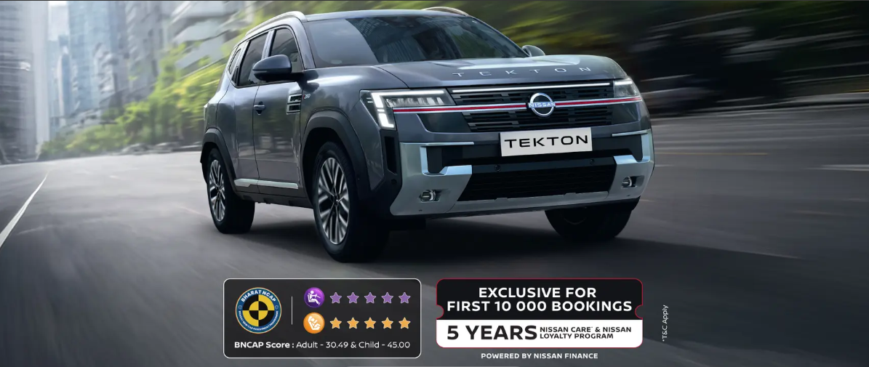
Nissan has always had a special place in the hearts of SUV lovers, and with the launch of the all-new Nissan TEKTON, the brand is once again ready to make heads turn on Indian roads. Built to celebrate 75 years of Nissan SUV excellence, the TEKTON draws inspiration from the legendary Nissan Patrol and blends that heritage with modern-day technology, premium comfort, and bold styling. If you have been searching for a mid-size SUV that looks powerful, feels luxurious, and comes packed with segment-leading features, then TEKTON deserves a serious look.
In this detailed article on BikeCarHub, we take a deep dive into everything the Nissan TEKTON has to offer — from its design philosophy and interior luxury to its engine options, safety suite, connectivity features, variants, and pricing. Whether you're a first-time SUV buyer or someone looking to upgrade, this guide from BikeCarHub will help you understand why TEKTON is being called "Unmistakable" by Nissan itself.
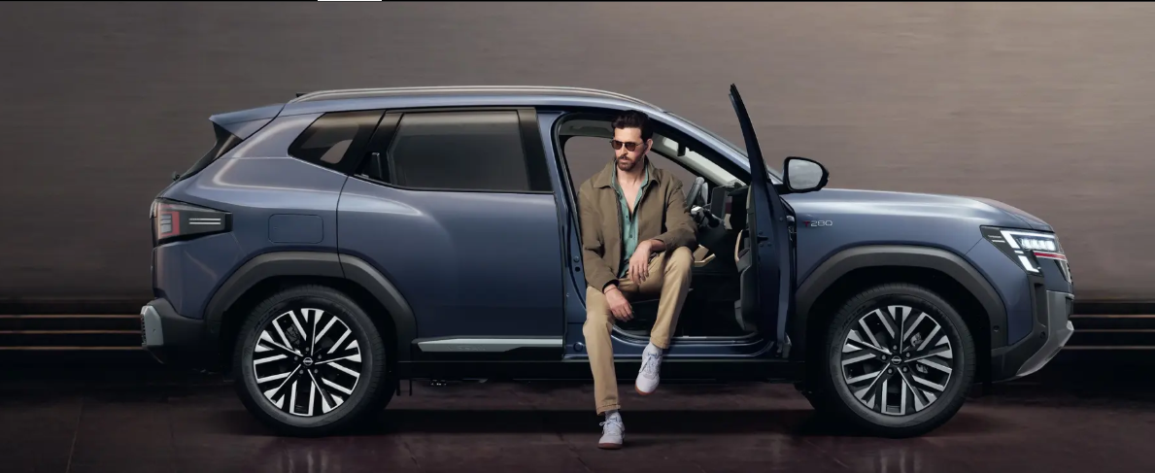

A Quick Introduction To The Nissan TEKTON
The Nissan TEKTON is a premium mid-size SUV that has been engineered to "disrupt" the segment, quite literally. Nissan describes it as a vehicle designed to make soul-stirring impressions, and after going through the brochure in detail, it's easy to see why. The design pays homage to the Nissan Patrol — one of the most iconic SUV nameplates in automotive history — while still feeling thoroughly modern with its sculpted body lines, muscular wheel arches, and aero-tuned details.
At BikeCarHub, we believe TEKTON is positioned to compete strongly in the crowded mid-size SUV segment, thanks to its combination of powerful turbo-petrol engines, a genuinely premium cabin, and a long list of advanced driver assistance features that were once reserved for much more expensive vehicles.
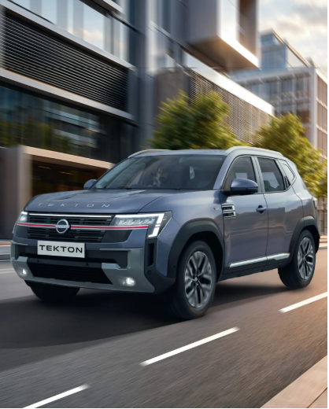

Nissan TEKTON Price In India
Let's get straight to the number most readers want to know first. The Nissan TEKTON is priced from ₹10.49 lakh to ₹18.59 lakh (ex-showroom), depending on the variant, engine, and transmission you choose. This pricing places TEKTON right in the middle of the competitive mid-size SUV segment, offering buyers a wide spread of choices — from a value-focused base variant to a fully loaded flagship trim packed with luxury and technology.
Given the amount of equipment on offer, especially in the higher trims, TEKTON appears to offer strong value for money. We'll break down what each variant brings to the table a little later in this article.

Design & Exterior: Unmistakable Presence
Nissan has clearly put a lot of thought into how the TEKTON looks, and the brochure makes it a point to highlight this throughout. The overall theme is "Unmistakable Presence," and it's built around three core design pillars:

Premium Presence
The TEKTON is styled to disrupt the segment with a bold stance that immediately draws attention on the road.

Commanding Silhouette
Sculpted lines and muscular wheel arches give the SUV a strong, athletic profile from every angle.

Bold Aerodynamism
Aero-tuned spoilers and flush roof rails aren't just for looks — they also contribute to better aerodynamic efficiency.

Daring Front Fascia
Up front, TEKTON gets a full-width, Patrol-inspired chrome accent grille paired with a Double-C contrast skid plate. The signature C-Shaped 5-chamber LED connecting headlamps give the SUV a distinctive lighting signature that's hard to miss, day or night.

Dominating Rear Design
At the back, TEKTON continues the same design language with SynchroFlow C-Shaped connected LED tail lamps that stretch across the width of the tailgate, giving it a wide, planted look from behind.

Wheels & Badging
The TEKTON rides on distinctive 5-petal brushed silver and Noir R18 diamond-cut alloy wheels on higher variants, adding a touch of sportiness. There's also a unique "Badge of Exploration" — a Himalayan Crest design finished in piano black on the C-pillar, symbolizing the human spirit of adventure, along with a rose gold "Ni-San" insignia detail inside the cabin that pays tribute to the brand name itself.

Interior & Comfort: Unmistakable Luxury
Step inside the TEKTON, and Nissan promises what it calls "Unmistakable Luxury." The cabin is finished with premium leatherette, soft-touch materials, bespoke stitching, and Japanese craftsmanship throughout, wrapped around the driver in a distinctive tri-tone colour scheme.

Tri-Tone Interior Theme
The top-spec cabin features a striking combination of premium beige, burgundy, and rose gold accents that bring a sense of contemporary elegance rarely seen at this price point.

Command Centre For The Driver
TEKTON's cockpit has been ergonomically designed with a Double D-cut steering wheel, dual driver-focused digital screens, an elevated centre console with a fly-by-wire E-shifter, and a comprehensive suite of electronic vehicle controls, all placed within easy reach.

Seating Comfort
- Active Comfort Seats: Powered, ventilated, and lumbar-adjustable, with an adjustable boomerang-profile headrest for extra support on long drives.
- Lounge Seating: The rear bench features waterfall-inspired bespoke stitching along with independently adjustable headrests, letting rear passengers travel in comfort.

Panoramic Sunroof
Nissan has equipped the TEKTON with a large panoramic sunroof that includes anti-pinch protection and one-touch control, giving the cabin an airy, open feel.
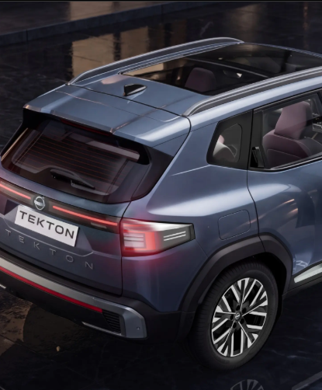

Mood Lighting & Sound
Passengers can personalise the ambience with 48-hue mood lighting spread across the dual screens, dashboard, and doors. For audio, the TEKTON comes with the Arkamys 3D Auditorium Surround Sound System, delivering rich, immersive acoustics for every playlist.

Climate & Convenience
- Voice-assisted dual-zone automatic climate control
- Smart air purifier with Plasmacluster Ionizer and AQI display
- Active-cooled wireless charging pad to keep devices powered on the move
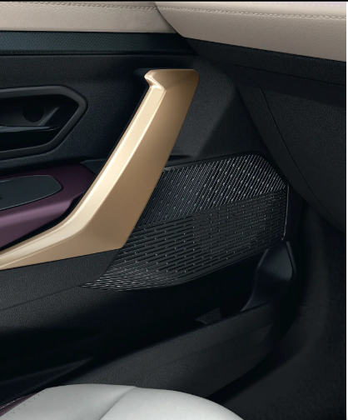

Technology & Connectivity: Unmistakable Connectivity
One of the standout aspects of the Nissan TEKTON, as highlighted repeatedly in the brochure, is its connectivity suite built around Google built-in technology.

Infotainment System
TEKTON comes with a 25.65cm (10.1-inch) Tek-Link HD infotainment system with Google built-in, allowing owners to simply say "Hey Google" to control navigation, music, climate, and more. The system supports up to 5 individual driver profiles, so the car recognises who's behind the wheel and adjusts settings accordingly.

Digital Cockpit
A 26.03cm (10.25-inch) HD digital cockpit with immersive Google Map view is available on higher trims, projecting turn-by-turn navigation directly in the driver's line of sight.

What Google Built-In Brings
- Google Maps – navigate confidently, even without a smartphone
- Google Assistant – voice control for AC, music, navigation, and more
- Google Play – access to 200+ Android apps for entertainment
- OTA Updates – the car keeps getting smarter with automatic software updates
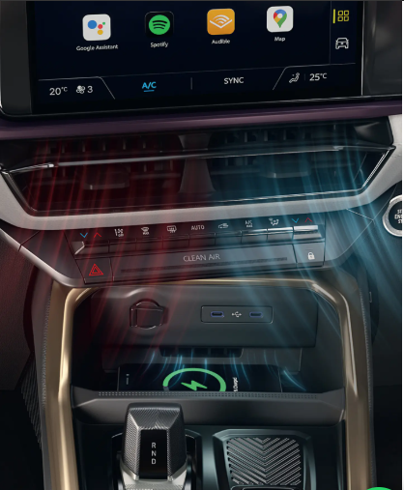

MyNISSAN App
Beyond the in-car system, Nissan also offers the MyNISSAN App, which brings over 55 connected features to your smartphone, including:
- Remote lock/unlock
- Remote engine start/stop with AC
- Remote horn & lights
- Remote vehicle status
- Find My Car
- Remind Me alerts
- Route to My Car
There's also a MyNISSAN Ownership section within the app covering account and vehicle info with warranty details, service booking, roadside assistance, dealership locator, document wallet, weather and air quality updates, and fuel/expense management — essentially turning your phone into a complete ownership companion.

Performance: Unmistakable Drive
Nissan is offering the TEKTON with two turbo-petrol engine options, giving buyers a choice between everyday efficiency and enthusiast-focused performance.

Turbo T160 – MPFi, 6-Speed Manual
Engineered for those who want everyday performance with smooth refinement and exceptional efficiency.
- Max Power: 100PS @ 5000rpm
- Max Torque: 166Nm @ 2000-3750rpm
- 0-100 km/h: 12.46 seconds
- Fuel Efficiency: 19.4 km/l

Turbo T280 – GDi, 6-Speed Manual
Built for enthusiasts who enjoy complete control with exhilarating turbo performance.
- Max Power: 163PS @ 5250rpm
- Max Torque: 280Nm @ 2000-3500rpm (best in segment)
- 0-100 km/h: 9.51 seconds
- Fuel Efficiency: 17.8 km/l

Turbo T280 – GDi, 6-Speed Wet Clutch DCT with E-Shifter
Crafted for effortless performance and refined comfort.
- Max Power: 163PS @ 5250rpm
- Max Torque: 280Nm @ 2000-3500rpm (best in segment)
- 0-100 km/h: 9.89 seconds
- Fuel Efficiency: 18.5 km/l
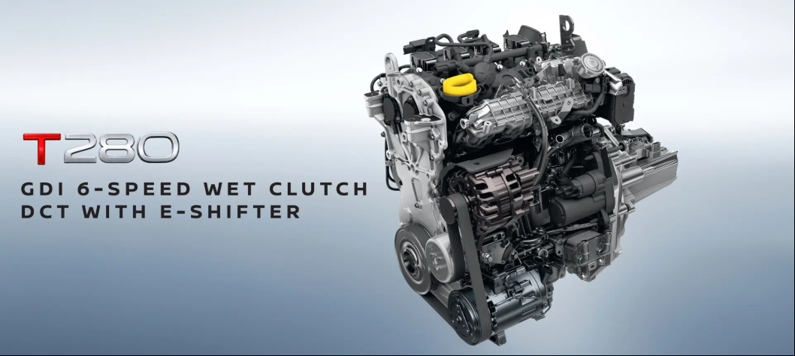

Driving Enhancements
- Fly-By-Wire E-Shifter for effortless drive mode selection (available on 6-speed DCT with wet clutch)
- Paddle Shifters mounted on the steering for a more engaging drive
- Dual-Drive Mode with dedicated mood lighting for Eco and Comfort settings
- Dual-Mode Steering allowing drivers to select low effort for city driving or high effort for high-speed stability, adjustable through the infotainment screen
- Suspension Setup: Tuned shock absorbers and dual anti-roll bars for composed handling at all speeds
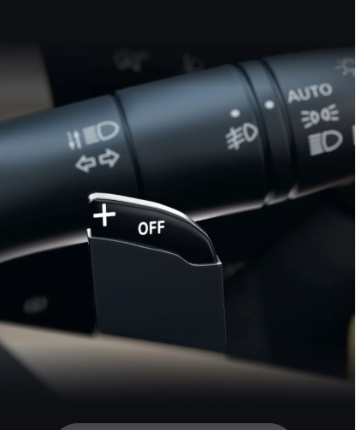
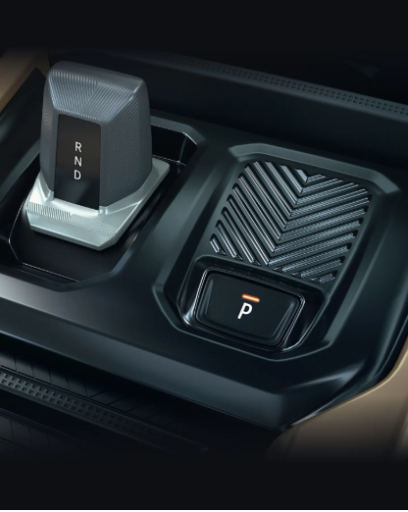

Safety: Unmistakable Safety
Safety is clearly a priority for Nissan with the TEKTON, and the numbers back this up. The SUV comes with a 5-star Bharat NCAP rating, 6 airbags as standard, over 40 standard safety features, and a body shell made from 62% high-strength and ultra-high-strength steel in critical zones like the A and B pillars.
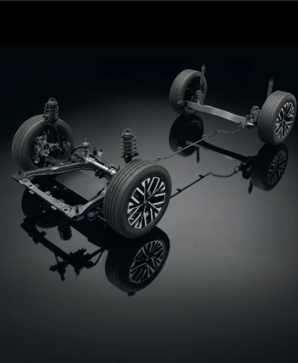

BNCAP Score
- Adult Protection: 30.49
- Child Protection: 45.00

Reinforced Body Structure
The monocoque body-shell uses a combination of ultra-high-strength steel and high-strength steel around the cabin structure to improve rigidity and occupant protection in the event of a collision.

Active Safety Systems
- Traction Control System (TCS): Prevents wheel slip, especially on wet and uneven roads
- Electronic Stability Control (ESC): Helps prevent skidding and loss of control on challenging roads

ADAS Suite – Up To 17 Features
TEKTON comes equipped with a comprehensive Advanced Driver Assistance System suite, including:
- Adaptive Cruise Control with Stop & Go
- Autonomous Emergency Braking (Urban, Pedestrian, and Cyclist detection)
- Lane Keep Assist
- Lane Departure Warning
- Blind Spot Warning
- Traffic Sign Recognition
- Driver Drowsiness Attention Warning
- Automatic High Beam Assist
- Front and Rear Parking Assist
- Rear View Camera with Dynamic Guideline
- 3D Intelligent Around View Monitor with 360-degree parking assist (12 sensors and 4 cameras)
These features work together to keep drivers aware of their surroundings and help avoid potential collisions, making TEKTON one of the more safety-focused options in its segment.

Boot Space & Practicality: Room For More
Nissan has designed the TEKTON to be a genuinely practical family SUV. It offers a class-leading 700 litres of boot space with the rear seats up (518 litres up to the parcel shelf), and this expands to a massive 1789 litres with the rear seats folded down — plenty of room for long family road trips or a big grocery run.
The tailgate itself is smart and powered, with anti-pinch protection for one-touch access, and a low loading edge that makes it easier to load heavy items without excessive lifting.
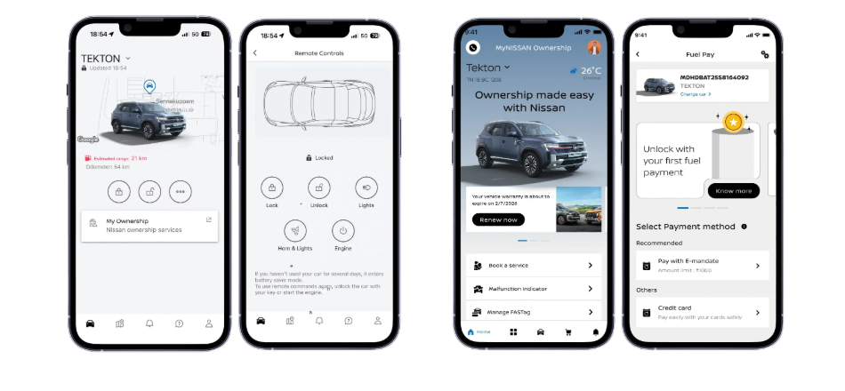

Intelligent Access
TEKTON also offers approach unlock and walkaway lock functionality, so the car welcomes you as you approach and secures itself automatically as you walk away — no need to fumble for buttons.

Nissan TEKTON Variants Explained
The TEKTON is offered across six variants — Visia, Visia+, Acenta, N-Connecta, Tekna, and Tekna+ — each adding a progressively richer set of features. Here's a breakdown of what each trim brings to the table, as covered on BikeCarHub.

Visia (Base Variant)
The entry-level Visia still comes well-equipped with Matrix Vision LED headlamps, signature C-shaped LED DRLs and tail lamps, R17 steel wheels, a 17.78cm (7-inch) Advanced Drive-Assist display, Arkamys signature sound with 4 speakers, driver and passenger front and side airbags, curtain airbags, ABS with EBD, ESC, TCS, hill start assist, and rear parking sensors.

Visia+ (Optional Package)
Builds on Visia with a 22.86cm (9-inch) floating touchscreen infotainment system, wireless Android Auto and Apple CarPlay connectivity, steering-mounted audio controls, and a rear view camera with dynamic guideline.
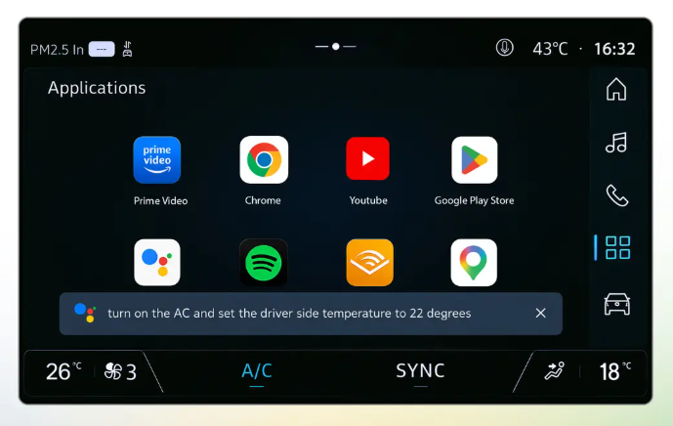

Acenta
Adds R17 wheels with dual-tone wheel covers, an aerodynamic flush roof rail, cruise control and speed limiter (DCT only), electronic parking brake (DCT only), a 25.65cm (10.1-inch) Tek-Link HD infotainment system, wireless Android Auto and Apple CarPlay, rear 60-40 seat split, rear centre armrest, and 2 front fast-charging USB Type-C ports.

N-Connecta
This mid-tier variant introduces an electric panoramic sunroof, R18 gunmetal satin alloy wheels, Matrix Vision C-shaped connected headlamps, SynchroFlow connected LED tail lamps, dual-zone auto air conditioning, a 26.03cm (10.25-inch) HD digital cockpit display, Arkamys Auditorium 3D surround sound with 6 speakers, and nautical blue leatherette accents.
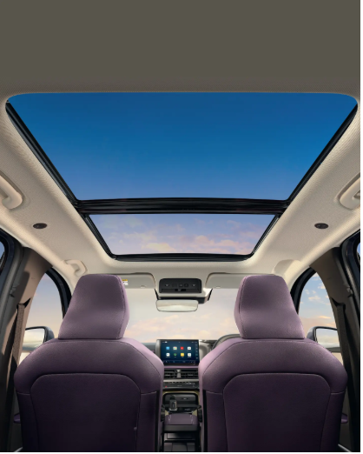
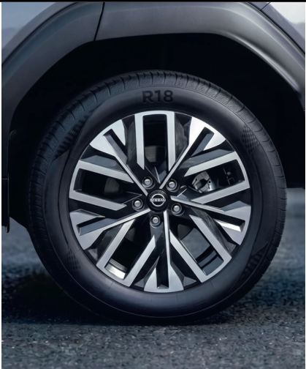
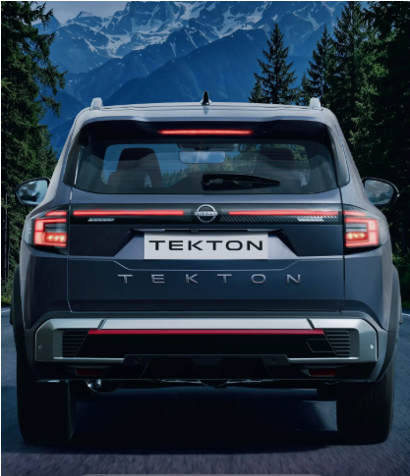

Tekna
Steps things up further with distinctive R18 diamond-cut 5-petal alloy wheels, rain-sensing frameless wipers, a smart air purifier with Plasmacluster Ionizer and AQI, a 6-way electrically adjustable driver seat, ventilated front seats, 48-colour mood lighting, dual drive modes (Eco and Comfort), and a 15-feature ADAS suite including AEB, ACC with Stop & Go, LDW, and LKA.

Tekna+ (Top Variant)
The flagship trim adds an electric powered tailgate, 6-way electrically adjustable front seats, the luxurious tri-tone soft-touch interior in burgundy, beige, and rose gold, a full drive map in the driver display, a 17-feature ADAS suite with 3D Intelligent Around View Monitor, and the complete 55+ feature MyNISSAN App and Google built-in connectivity suite, including Car to Home functionality and OTA updates.
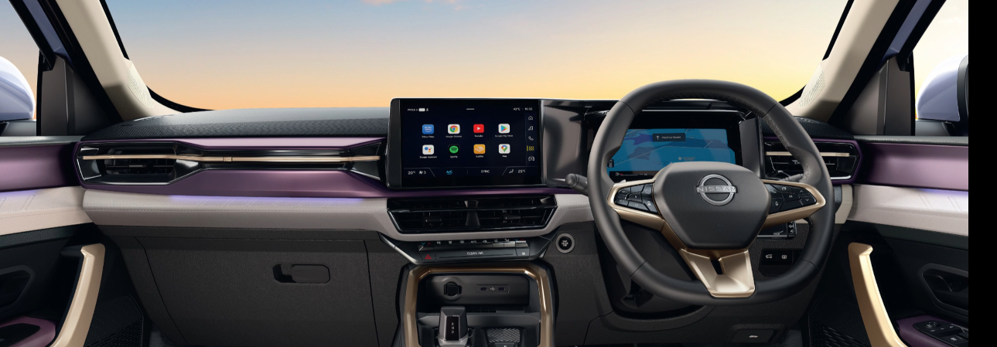

Nissan TEKTON: Specifications & Features Table
Specification | Turbo T160 | Turbo T280
Fuel Type | Petrol - E20 | Petrol - E20
Fuel System | Turbo MPFi | Turbo GDi
Displacement | 999cc, 3-Cylinder | 1333cc, 4-Cylinder
Max Power | 100PS @ 5000rpm | 163PS @ 5250rpm
Max Torque | 166Nm @ 2000-3750rpm | 280Nm @ 2000-3500rpm
Transmission | 6-Speed Manual | 6-Speed Manual / 6-Speed DCT with Wet Clutch
Length x Width x Height | 4349 x 1815 x 1674mm | 4349 x 1815 x 1674mm
Wheelbase | 2657mm | 2657mm
Ground Clearance | 212mm | 212mm
Boot Space | 700L (1789L seats folded) | 700L (1789L seats folded)
Fuel Tank Capacity | 50L | 50L
Front Suspension | MacPherson Strut with Lower Transverse Link | Same
Rear Suspension | Twist Beam Suspension with Coil Spring | Same
Front Brakes | Disc | Disc
Rear Brakes | Disc (Tekna/Tekna+/DCT) / Drum (other variants) | Same

Nissan TEKTON Variant Comparison Table
Feature | Visia | Visia+ | Acenta | N-Connecta | Tekna | Tekna+
Wheels | R17 Steel | R17 Steel DT | R17 Steel DT | R18 Gunmetal Alloy | R18 Diamond Cut | R18 Diamond Cut
Infotainment | 7-in Display | 9-in Touch | 10.1-in Tek-Link | 10.1-in Tek-Link | 10.1-in Tek-Link | 10.1-in Google Built-in
Digital Cockpit | No | No | No | 10.25-in HD | 10.25-in HD | 10.25-in Google Map View
Sunroof | No | No | No | Electric Panoramic | Electric Panoramic | Electric Panoramic
Ventilated Seats | No | No | No | No | Yes | Yes
ADAS Features | Basic Safety | Basic + RVC | Basic + RVC | Basic Suite | 15 Features | 17 Features
Powered Tailgate | No | No | No | No | No | Yes
Google Built-in | No | No | No | No | No | Yes
Airbags | 6 | 6 | 6 | 6 | 6 | 6
Engine Options | T160 Only | T160 Only | T160/T280 DCT | T160/T280 MT/DCT | T160/T280 MT/DCT | T160/T280 DCT
Note: Feature availability may vary slightly by market and is subject to change. Please confirm with your nearest Nissan dealer for the latest specifications.

Nissan TEKTON Colour Options
The TEKTON is available in a wide range of monotone and dual-tone shades depending on the variant, including Onyx Black, Blade Silver, Pearl White, Flare Garnet Red, Indigo Blue, and Moonbow Gray. The top-spec Tekna+ variant also offers striking dual-tone combinations such as Pearl White & Onyx Black, Flare Garnet Red & Onyx Black, Indigo Blue & Onyx Black, Blade Silver & Onyx Black, and Moonbow Gray & Onyx Black, giving buyers plenty of ways to personalise their SUV.

Genuine Accessories For Personalisation
For those who like to customise their ride further, Nissan offers a range of genuine accessories for the TEKTON, including a dual dash cam, Joie child seat, illuminated side steps, wireless charger, reversible luggage mat, premium cabin carpet mats, satin chrome tailgate finisher, satin chrome ORVM embellishment, illuminated kicking plates, magnetic window sunshades, and satin chrome door visors. A SkyLounge ambient light feature is also available, though this falls outside the standard genuine accessories range.
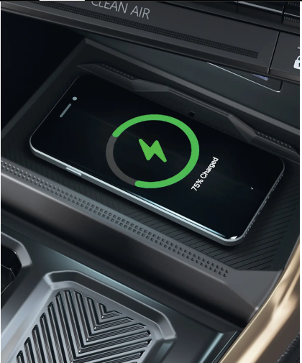

Ownership & After-Sales: Unmistakable Nissan Care
Nissan backs the TEKTON with a solid ownership promise that should give buyers peace of mind.

Standard (Included In Vehicle Cost)
- Warranty: Up to 3 years / 1,00,000 km
- Roadside Assistance (RSA): 3 years, 24/7

Paid (Available At Additional Cost)
- Extended Warranty: Up to 10 years / 2,00,000 km
- Maintenance Plan: 3 years / 30,000 km
Owners can also reach Nissan's 24/7 roadside assistance helpline at 1800-209-3456 whenever needed, and the brand's dealership network continues to expand across the country to bring service closer to customers.

Why Choose The Nissan TEKTON?
After going through everything the TEKTON has to offer, it's clear that Nissan has tried to pack in a genuinely premium experience at a competitive starting price. A few reasons this SUV stands out:
- Bold, Patrol-Inspired Design that gives it real road presence
- Two Turbo-Petrol Engines offering a choice between efficiency and performance
- Best-in-segment torque of 280Nm on the T280 engine
- Class-leading boot space of 700 litres (1789L with seats folded)
- Comprehensive ADAS suite with up to 17 safety features
- 5-star Bharat NCAP safety rating
- Google built-in connectivity with natural voice interaction
- Luxurious tri-tone cabin on the top-spec Tekna+ variant
- Strong ownership support with extended warranty options up to 10 years
At BikeCarHub, we feel that the Nissan TEKTON is shaping up to be one of the more compelling options for buyers who want an SUV that feels premium, drives confidently, and doesn't compromise on safety or technology.

Final Thoughts
The Nissan TEKTON marks a significant moment for the brand, as it looks to build on 75 years of SUV heritage while offering Indian buyers a genuinely feature-rich, safety-focused, and comfortable family SUV. With its bold design, powerful engine options, premium interior, and a long list of connected and safety technologies, the TEKTON has all the ingredients to make a strong impression in its segment. For more detailed reviews, comparisons, and the latest updates on new car launches, keep following BikeCarHub.

Frequently Asked Questions About Nissan TEKTON
1. What is the price of the Nissan TEKTON?
The Nissan TEKTON is priced from ₹10.49 lakh to ₹18.59 lakh (ex-showroom), depending on the variant and engine chosen.
2. What engine options are available in the Nissan TEKTON?
The TEKTON is offered with two turbo-petrol engines — a 999cc Turbo T160 MPFi unit producing 100PS/166Nm, and a 1333cc Turbo T280 GDi unit producing 163PS/280Nm, available with manual and DCT transmission options.
3. What is the boot space of the Nissan TEKTON?
The TEKTON offers 700 litres of boot space with the rear seats up, which expands to 1789 litres when the rear seats are folded down.
4. Does the Nissan TEKTON get a sunroof?
Yes, the TEKTON comes with an electric panoramic sunroof with anti-pinch protection and one-touch control, available from the N-Connecta variant upwards.
5. What is the safety rating of the Nissan TEKTON?
The Nissan TEKTON has received a 5-star Bharat NCAP safety rating, with 6 airbags as standard across all variants.
6. Does the Nissan TEKTON support Google built-in?
Yes, the top-spec Tekna+ variant comes with Google built-in technology, offering Google Maps, Google Assistant, and Google Play integrated directly into the infotainment system.
7. How many variants does the Nissan TEKTON come in?
The TEKTON is available in six variants: Visia, Visia+, Acenta, N-Connecta, Tekna, and Tekna+.
8. What ADAS features are available in the Nissan TEKTON?
Depending on the variant, TEKTON offers up to 17 ADAS features, including Adaptive Cruise Control, Autonomous Emergency Braking, Lane Keep Assist, Lane Departure Warning, Blind Spot Warning, and a 3D Intelligent Around View Monitor.
9. What is the warranty offered on the Nissan TEKTON?
The TEKTON comes with a standard warranty of up to 3 years/1,00,000 km, along with an optional extended warranty package of up to 10 years/2,00,000 km.
10. What colours are available for the Nissan TEKTON?
The TEKTON is available in Onyx Black, Blade Silver, Pearl White, Flare Garnet Red, Indigo Blue, and Moonbow Gray, along with several dual-tone options on the Tekna+ variant.

SEO Details
Title Tag: Nissan TEKTON Price, Specs & Features | BikeCarHub
Meta Description: Explore Nissan TEKTON price, specs, variants, engine options, safety features & more. Read the complete review on BikeCarHub before you buy.
SEO Keywords: Nissan TEKTON, Nissan TEKTON price, Nissan TEKTON review, Nissan TEKTON specifications, Nissan TEKTON features, Nissan TEKTON variants, Nissan TEKTON mileage, Nissan TEKTON interior, Nissan TEKTON engine, Nissan TEKTON safety rating, Nissan TEKTON colours, Nissan TEKTON on-road price, Nissan SUV 2026, Nissan TEKTON vs competitors, Nissan TEKTON Tekna+, BikeCarHub Nissan TEKTON

